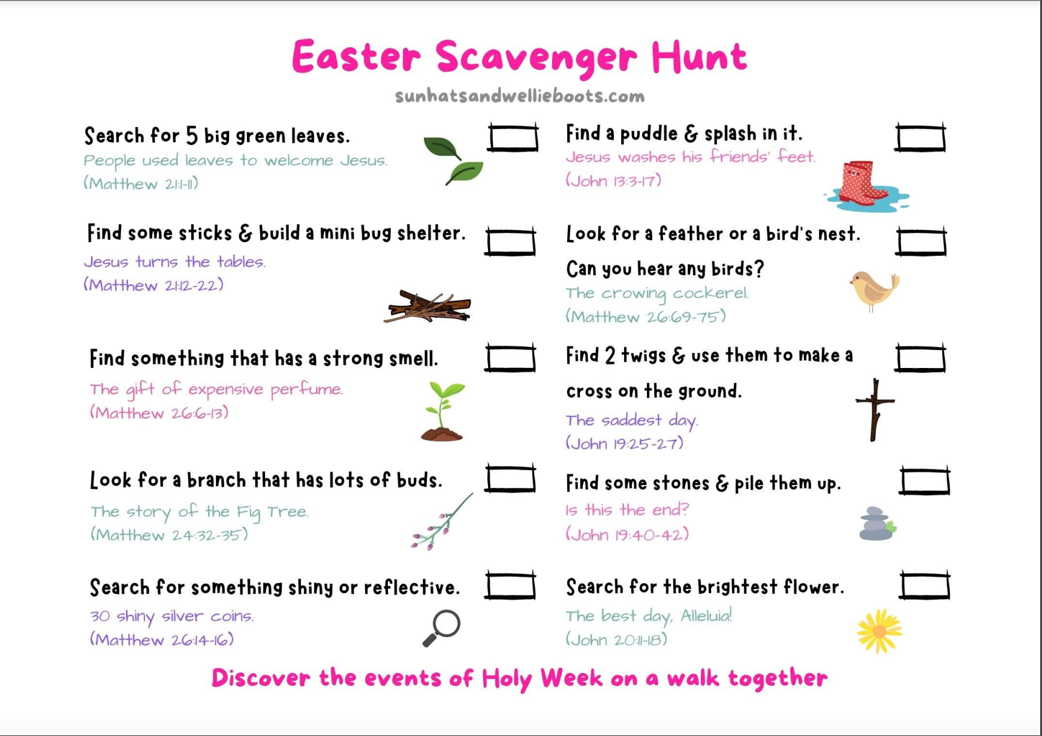

If you’re using this resource with internet capability, click on the links for Bible story online

