**One, Holy, Catholic, Apostolic CHURCH**

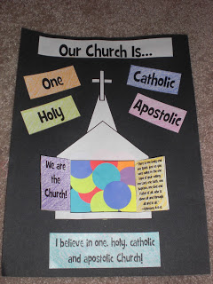

Thanks <https://www.looktohimandberadiant.com/2012/08/we-are-church-craft.html>

**ONE** – we are ONE church, everyone everywhere who follows Jesus, even if we go to different churches on a Sunday.

**HOLY** – The Church is Jesus’ bride, good & holy – even though it’s made up of broken and fallen people. We try to live holy lives.

**CATHOLIC** – this word means UNIVERSAL: for all people, in all cultures, at all times – Anyone anywhere can follow Jesus & be part of Church

**APOSTOLIC** – the Church follows the teachings of the Apostles (Jesus’ disciples) and this has been passed on to us through Bishops & Church leaders through the ages.

Have you thought about what these words mean? We say them when we say the Nicene Creed on Church: a statement of what we believe. Can you say in your own words what they mean?

Glue the outside of the church (not the doors!) over the coloured circles, so they are behind the open doors.

Stick all the words on around the church

Cut all the pieces out from the printed sheet, including the doors of the church, so they can be opened

Cut circles or shapes from different coloured pieces of paper – to show we are all different, then glue them down overlapping in the space where the doors will be.  
(You might like to make the area on your background sheet first)