Churchwardens – St Ann with Emmanuel

Role Title: | Churchwarden

Role Purpose: | Churchwardens are to co-operate with and support the Vicar in leading the PCC in its role of promoting the mission of the church in the parish. Churchwardens are the foremost in representing the laity and are officers of the Bishop.  Churchwardens will try by their example and faith to encourage the parishoners in the day to day living out of their faith, to promote peace and unity among them and to ensure the smooth running of the church.
Support: | Churchwardens are supported by the Bishop, the Archdeacon, Area Dean and are encouraged to utilise the various support teams working for the Diocese

1. | To co-operate with the parish priest in leading the PCC in its role of promoting the whole mission of the church in the parish – pastoral, evangelistic, social and ecumenical. There is also a role of overview, with the Vicar, in financial leadership of the church and in supporting the work of the PCC Treasurer. (If there is no treasurer, the churchwardens are responsible for this.)  Churchwardens attend PCC and APCM meetings.
2. | To meet and pray regularly with the Parish Priest, developing a shared vision of the parish’s life and mission. To care for the parish priest and the parish priest’s family.
3. | To care for the congregation; to encourage its members in the Christian faith,
4. | To help heal any quarrels or disagreements that arise between the congregation, or between the congregation and the parish priest. If there are any serious complaints about the state of the parish or the parish priest’s discharge of his/her duties churchwardens should make a serious attempt to deal with such complaints locally in a constructive and co-operative spirit. If this fails to resolve the situation the churchwardens report the matter to the bishop or archdeacon.
5. | To oversee the maintenance and administrative work in relation to the church building; trying to ensure that the parish priest does not have to. This does not mean doing all the work, but rather co-ordinating teams and volunteers to make sure required work is done. He/she should seek the help of other PCC members, the PCC treasurer and members of the congregation who can help with such things. To consult the archdeacon at the beginning stage of any proposal of work of maintenance, alteration or reorganisation within/to the church building. To keep the records up to date.
6. | To ensure order at Sunday services and that all worshippers are welcomed, especially visitors. In practise this is delegated to the sidespeople/welcome team; the churchwarden should ensure a rota is in place and that all sidespeople are trained. Churchwardens are responsible for ensuring that collections are taken and after the service ensure that the service registers are completed, including the recording of collections taken and monies banked.
7. | To provide annual written reports to APCM
8. | During a vacancy churchwardens have special duties e.g. arranging for someone to take Holy Communion each week, in conjunction with the church office and area dean, and be involved in the choosing of the new parish priest.
9. | Churchwardens must attend the Archdeacons Visitation and at least one relevant training session per year when these are offered, including safeguarding. Churchwardens should take responsibility for their own discipleship and be ever seeking to be closer to Jesus.
10. | They should be known to parishioners and available to them, and should promote peace and unity within the congregation and community.
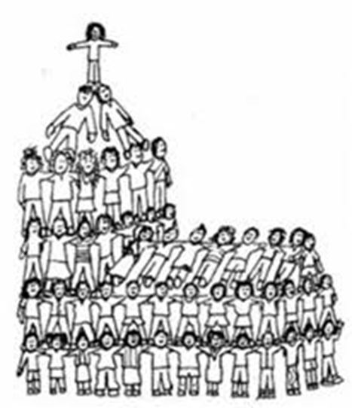
Care for buildings -
ensuring admin & jobs done
Care for clergy -practical & spiritual

Care for congregation –
promoting unity

