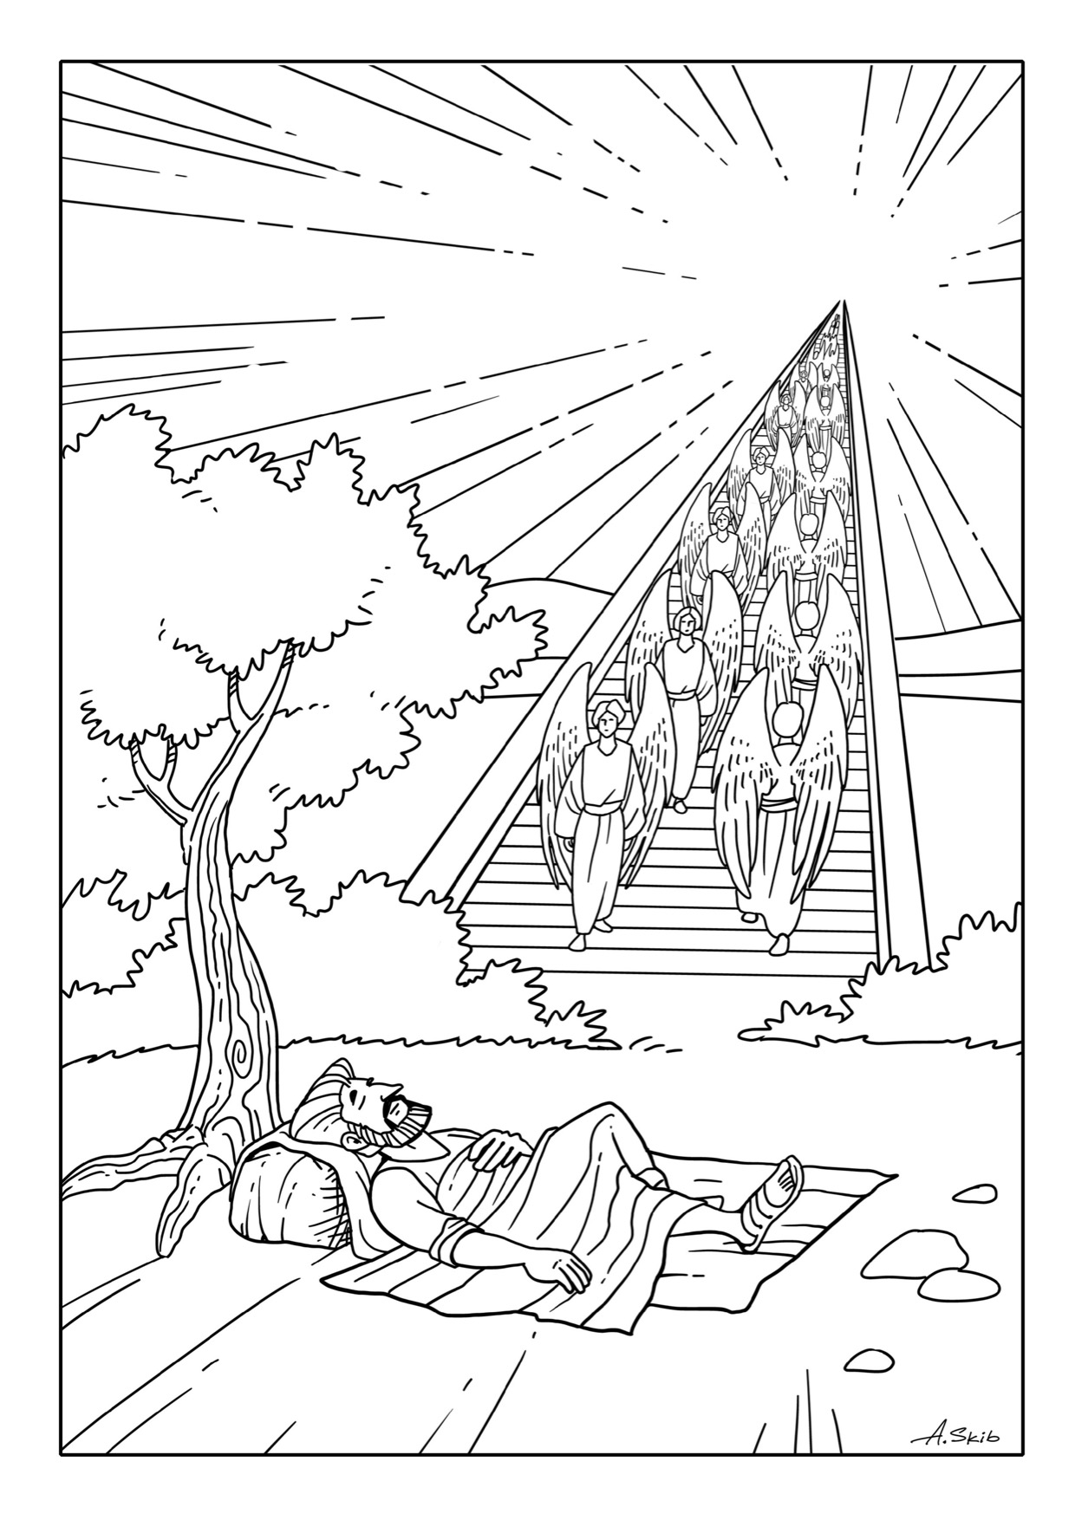
Can you colour this picture,
or draw what you imagine it might have looked like?

