“tsp”
A simple way to pray
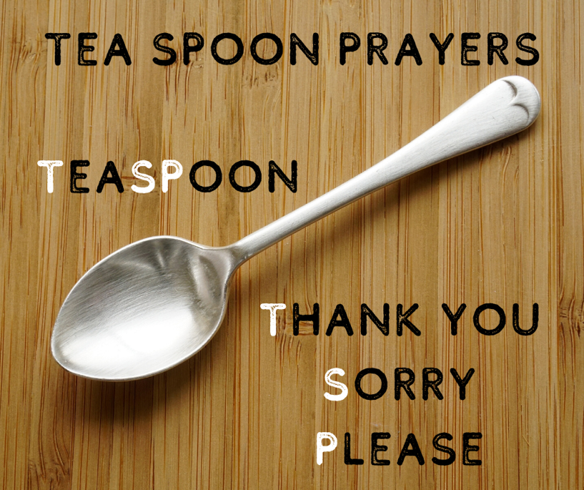
*Thank you
What are you grateful for today?
Being alive? Your family, friends, pets? Somewhere special you’ve been or something lovely you’ve done today?
Every good and perfect gift is from above, coming down from the Father (James, Bible)
“Thank you God for…..”

*Sorry
We all make mistakes and do things we shouldn’t, or don’t do things we should! Then be sorry & ask God to forgive you.
If we confess our sins, he is faithful and just and will forgive us our sins (1 John, Bible)
“Dear God, I’m sorry for…..”

*Please
What would you like to ask God for? To help you with something, or a prayer for someone else?
Do not be anxious about anything, but in everything by prayer and with thanksgiving let your requests be made known to God. (Philippians, Bible)
“Please God would you….”

