There are all sorts of ways of reminding yourself to be grateful to God!

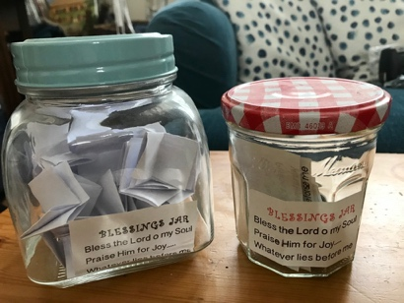
Remember that old song:
“Count your blessings, Name them one by one,
Count your blessings, see what God has done,
Count your blessings, Name them one by one,
And it will surprise you what the Lord has done!”

You could make a BLESSINGS JAR
Get an old jar and clean it/dry it well.
You might like to decorate the outside of it (you can use tissue paper and glue, or you can use permanent marker pens)
Then think of all the things you are grateful for, or happy about – all the blessings, big and small, that God has given you.
Write each one on a separate piece of paper and pop it in the jar.
(Family members, friends names, favourite foods, favourite places, special Bible verses….)
Then when you have a down day, go into your jar and find some things to remind you of God’s goodness and his abundance!

You could make your own THANKFULNESS POSTER
Find a big piece of paper and write THANK YOU GOD in the middle, then all around it write
All the things you are grateful for: people, places, foods, promises from God…..
Then stick it up somewhere to remind you of God’s goodness.

