 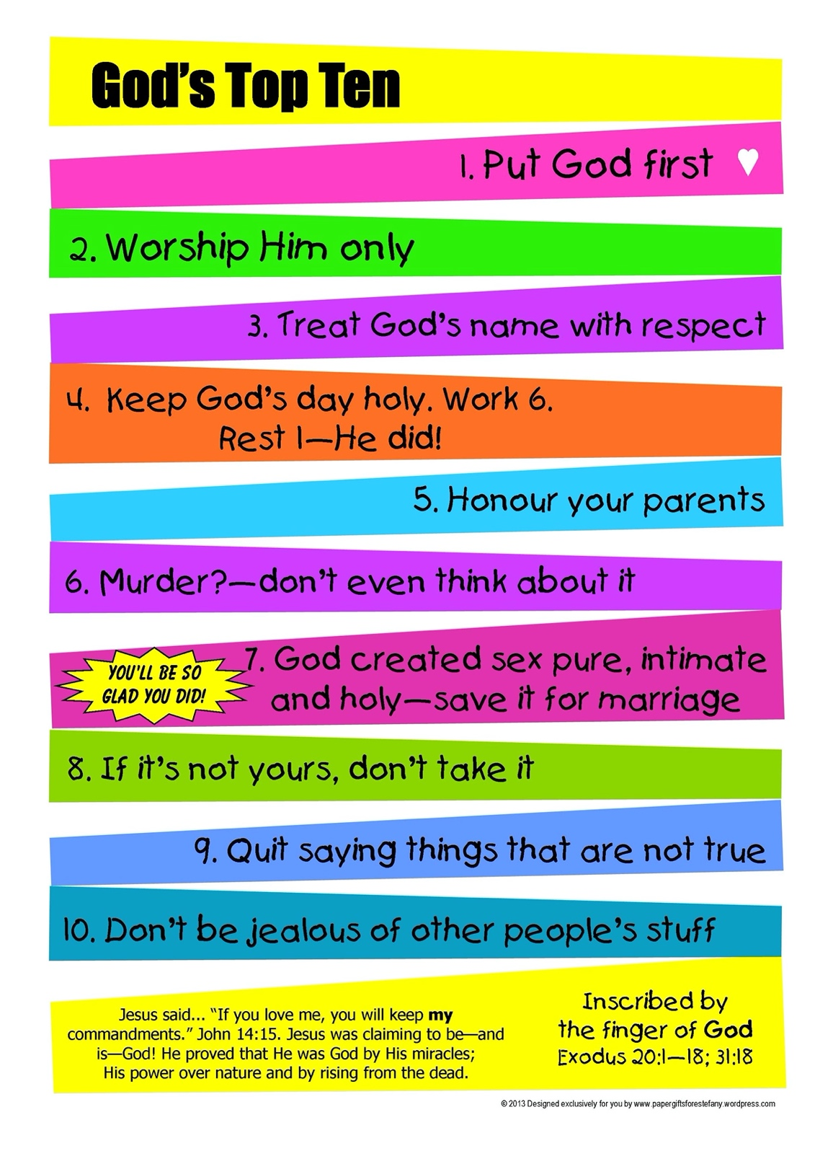

1. Do these remind you of anything you’ve heard before?
2. Look at Exodus 20:1-17 for a clue!
3. Can you make your own list – on the Jacob’s ladder sheet of things that will help you to get closer to God.