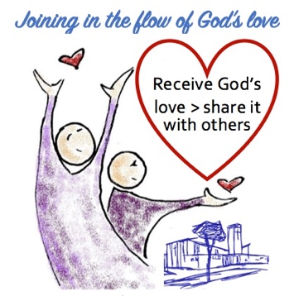
St Ann
with Emmanuel
Church

Robin Hood Chase, St Ann’s, NG3 4EY
(Car park: Church Road NG3 4EX)
Email: ChurchontheChase@gmail.com
Mobile: 07414275815
Vicarage: 0115 9505471
website: www.stannwithemmanuel.com
Find us on Facebook, Instagram, Twitter
www.youtube.com/@ChurchontheChase



We are a multicultural church family with a range of ages and types of people who are trying to follow Jesus. We want to keep on receiving God’s rich and abundant love as we worship Him, then get out of the building and share it with those around us
#Receive God’s Love and Share it with Others

When we meet on Sunday mornings there are usually between 60 and 70 adults, and around 20 children/young people. Our worship style tries to encompass a range of things that are important to different people. So, we have liturgy and informal prayer, we have a choir as well as a worship band, we sing hymns and contemporary worship songs. We like to involve people in our services and give people opportunities to try things and build confidence. Lots of people do Bible readings, lead the prayers and take part in other ways regardless of age, ethnicity, gender or educational background. Since Covid, we live-stream our services – where we regularly get 20+ views.

We work well with local groups including the Debt Advice/Community Centre, Food Bank, Nottingham Citizens, Police, Local Councillors etc. We seek to work within the community as part of it.
#BelievinginStAnn’s
There is so much more that could be done – so many initiatives that would make a difference in this sometimes struggling community. There is a lot of poverty and low expectations. There is a danger of young people being drawn into a culture of gangs and drugs. The government has recently invested a large sum to be spent in St Ann’s over 10 years “to restore pride, belonging and control to communities”- which raises more exciting possibilities!

We seek to be visible online through Live stream on YouTube, our website and some social media – which could be developed. We seek to have an open and welcoming building, which is well known and used in the community. Our building is easy to use and will become even more so with work on accessibility starting in Spring. We have a system in place for regular and occasional renters of the building, and there may be opportunity to increase this.

This is a friendly, happy church where an Operations Manager would be welcomed and appreciated. The PCC and key volunteers are supportive and have useful experience to share. The vicar is friendly and easy to work with.
Much is already in place but there is always room for improvement, and we hope the Ops Manger will be able to find ways to improve and streamline some of our systems.

If you are interested in developing systems to make things run smoothly…..
If you are happy to work in a multicultural ‘area of deprivation’ .….
If you would like to work in a welcoming church with a friendly and helpful vicar…..
We might just be the place for you! Let’s have a chat….
Rev Maureen Collins. revmaureenstanns@gmail.com 07414275815

