<https://biblehub.com/timeline/acts/1.htm>

**PETER**

<https://www.tyndale.com/stories/free-life-peter-time-line>

<https://georgesjournal.net/2023/08/18/peters-hills-and-valleys/>

**PAUL**

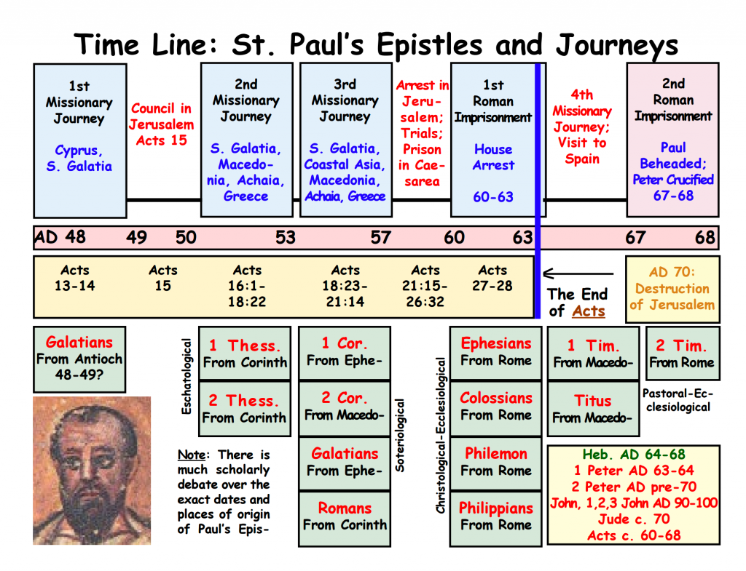

<https://catholicconvert.com/free-st-paul-timeline-in-honor-of-feast-of-pauls-conversion-today/>

<https://www.gotquestions.org/timeline-of-Pauls-life.html>

[**https://bibleproject.com/videos/2-timothy**](https://bibleproject.com/videos/2-timothy)