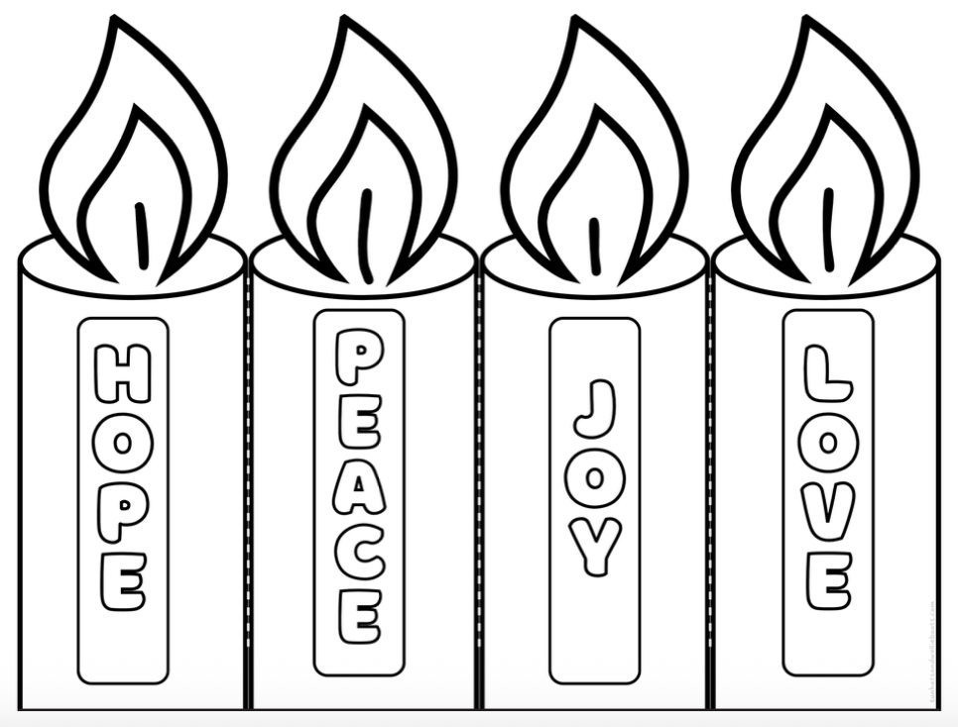
Advent
Advent is the time leading up to the birth of Jesus – on Christmas day.
We remember that Jesus brought hope, peace, joy and love into our world.
Some people light a candle each week to remember Jesus, the Light of the world.

