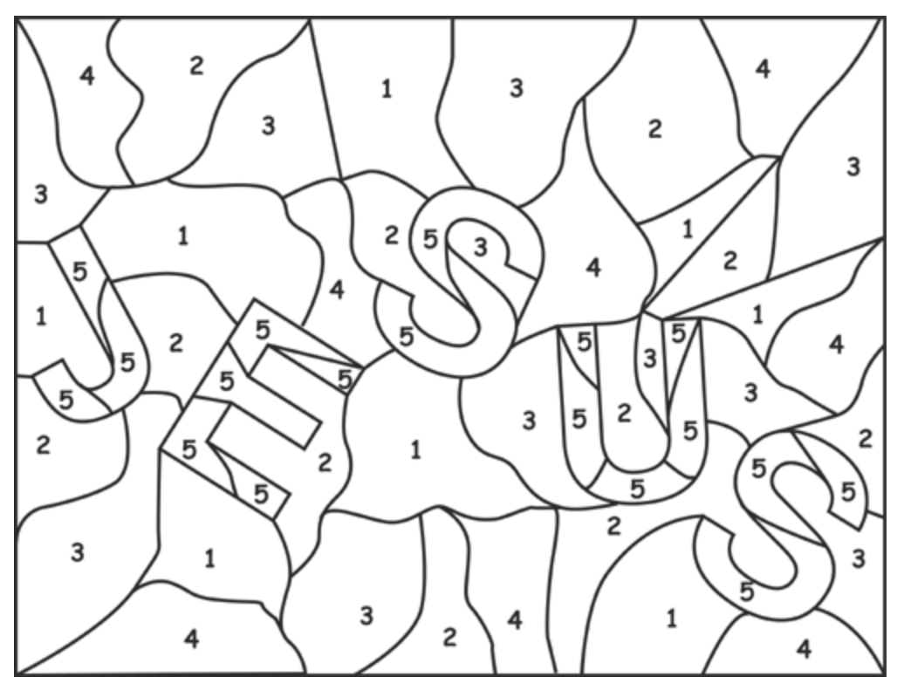
1=blue 2=green 3=brown 4=purple 5=bright yellow
(or choose your own colours!)

