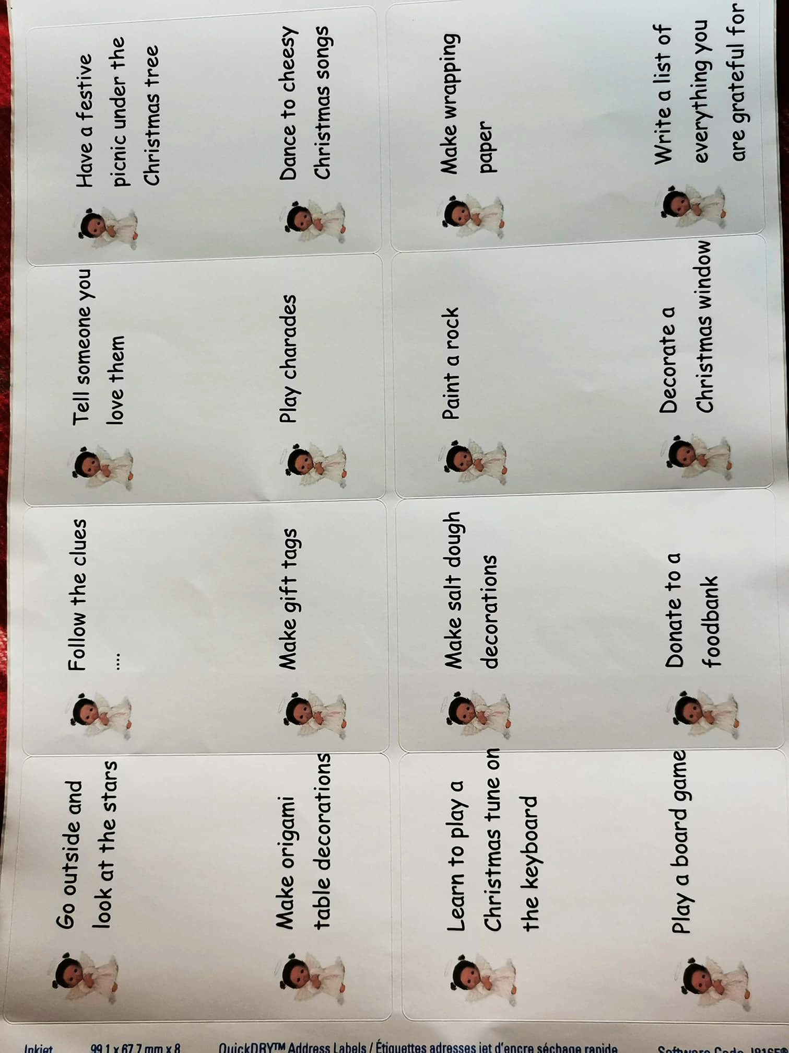
Make up your own idea or use these – put in your advent calendar pockets for children to do each day!
